***JUNE NEWS LETTER***

“Your children are the greatest gift God will give to you, and their soul to the heaviest responsibility He will place in your hands”. LISA WINGATE”

|  |  |  |
| --- | --- | --- |
| ***Dear parents***  It is hard to believe that we are half way down the year (mid-year).Time flies when you are having fun. We truly enjoy every day we share with our little ones. Your children have shown so much growth and development in all areas since January.  May was a great month for us, we are so overwhelmed with happiness after our launch for the new name “NEW KIDSCARE”NURSERY that was held on the 21st of May. Special thanks to our parents for coming in numbers and supporting us your presence was highly appreciated and also to our wonderful teachers for all your hard work.  NEW KIDSCARE NURSERY intend to give every child the best care and best education to every child at our school. For us to achieve the best we have introduced the EYLOG programme please parent’s lets communication with each other using it and updating our kid’s profile, and in the near future will also introduce smart classes.    Winter is here it’s getting colder everyday please make sure our little one is wearing warm clothes and have extra clothes in the bag. All children’s clothes need to be marked, be advised to send a warm small blanket to the school for your child to be covered during nap time. | ***Extra Mural Activities***   * Ballet class is growing bigger every week. * Action ball classes started last week please enroll your child. * Afrikaans classes are only for Grade R classes, they already started.   After care class have started Grade1-Grade7. Registration forms are available at the reception. | ***Important dates***  -16 JUN-Youth day(holiday)  -17 JUN –NEW KIDSCARE HOLIDAY  -02 AUG-trip to fire station Mabopane  -25 AUG- trip the Zoo  -06 Sep- Shoprite and KFC(shopping)  -26Sep-Grand-parents day(at school)  -24 Sep- Family Sport day(Giant stadium)  -22 Oct –Bela Bela(family trip)  -10 Nov- Animal show(at school)  -26 Nov-Graduation day &concert(Venue still to be announced) |
| ***Themes we have covered in May***   * Birds * Day and night * Fire and safety * Autum   In June we are starting with theme winter. |
| ***THANK YOU NOTE***  ***NEW KIDSCARE WOULD LIKE TO THANK ALL OUR GUESTS AND PARENTS FOR THE SUPPORT ON OUR LAUNCH DAY, IT WAS A SUCCESS AND ENJOYED BY ALL. THANKS TO OUR NEW KIDSCARE PUPIL THE PERFOMANCE WAS VERY WELL DONE AND NOT FORGETTING OUR NEW KIDSCARE TEAM THANK YOU VERY MUCH.*** |
| ***Fees***  Please be reminded that fees must be paid by the 1st of every month and also send the proof of payment. If not paid account will be handed to debt collectors. |
| ***Suggestion box***  There’s a suggestion box at school please drop in your suggests they will be highly appreciated |
| ***Winter vibes***  Every Thursday from June to July its pyjama day and indoor movies, 9June, 23June, 30June, 7July, 14july 21July, 28 July.  Every Friday is Tuck shop day. Please give our little one R5 on Fridays. Please support this day parents it trains our little one’s to be more responsible at an early age. |
| .  **OUR BIRTH DAYS** |  |

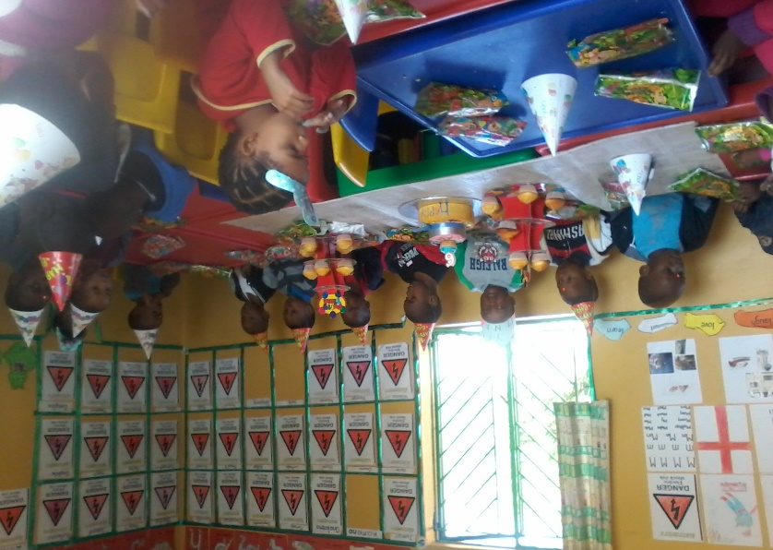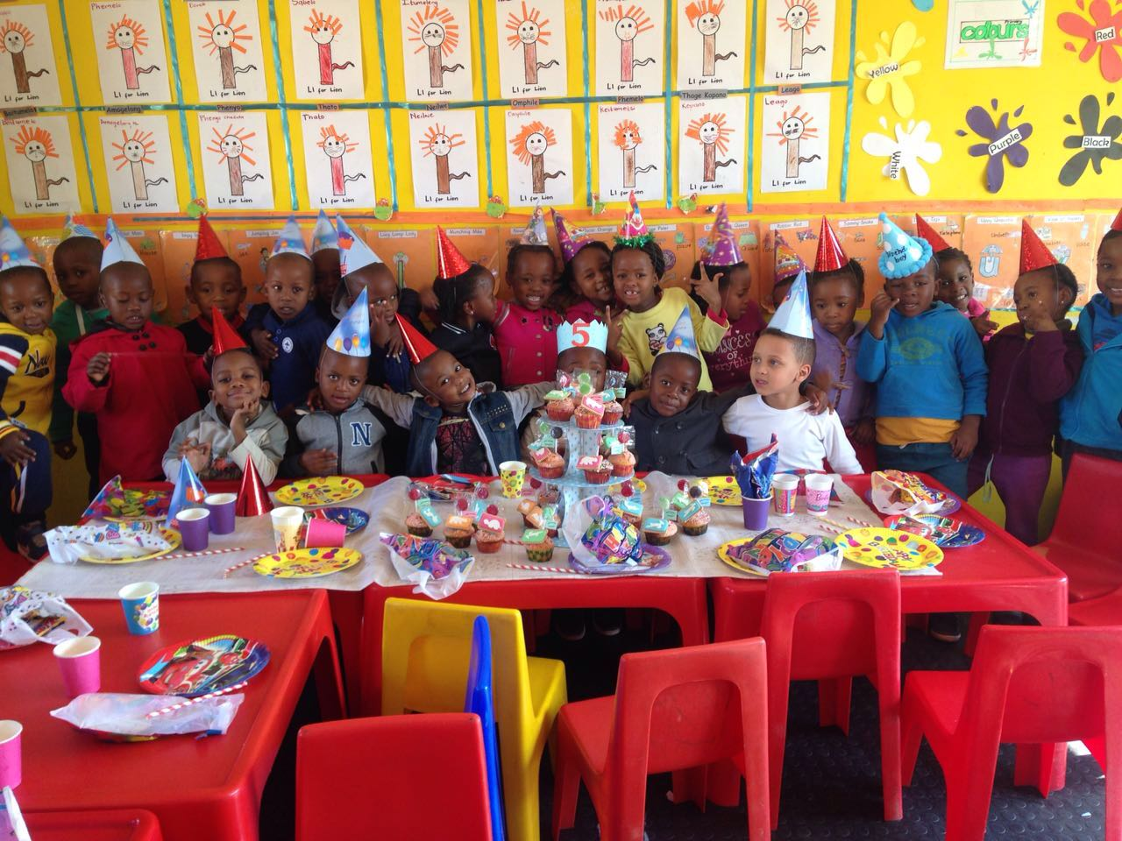

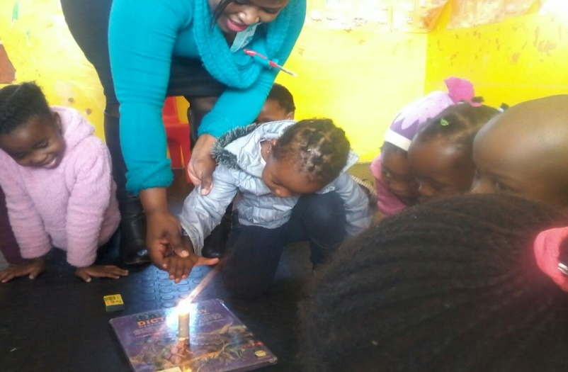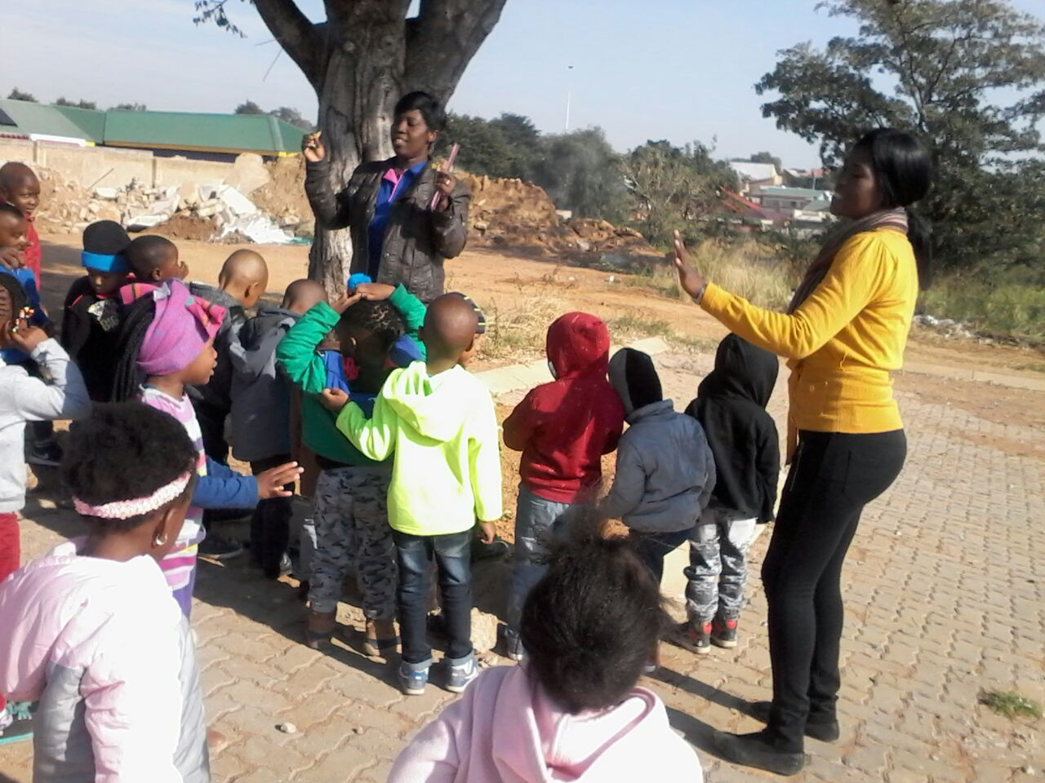**CHEETAH CLASS (FIRE&SAFETY)** **DRAGONFLY CLASS (AUTUMN THEME)**

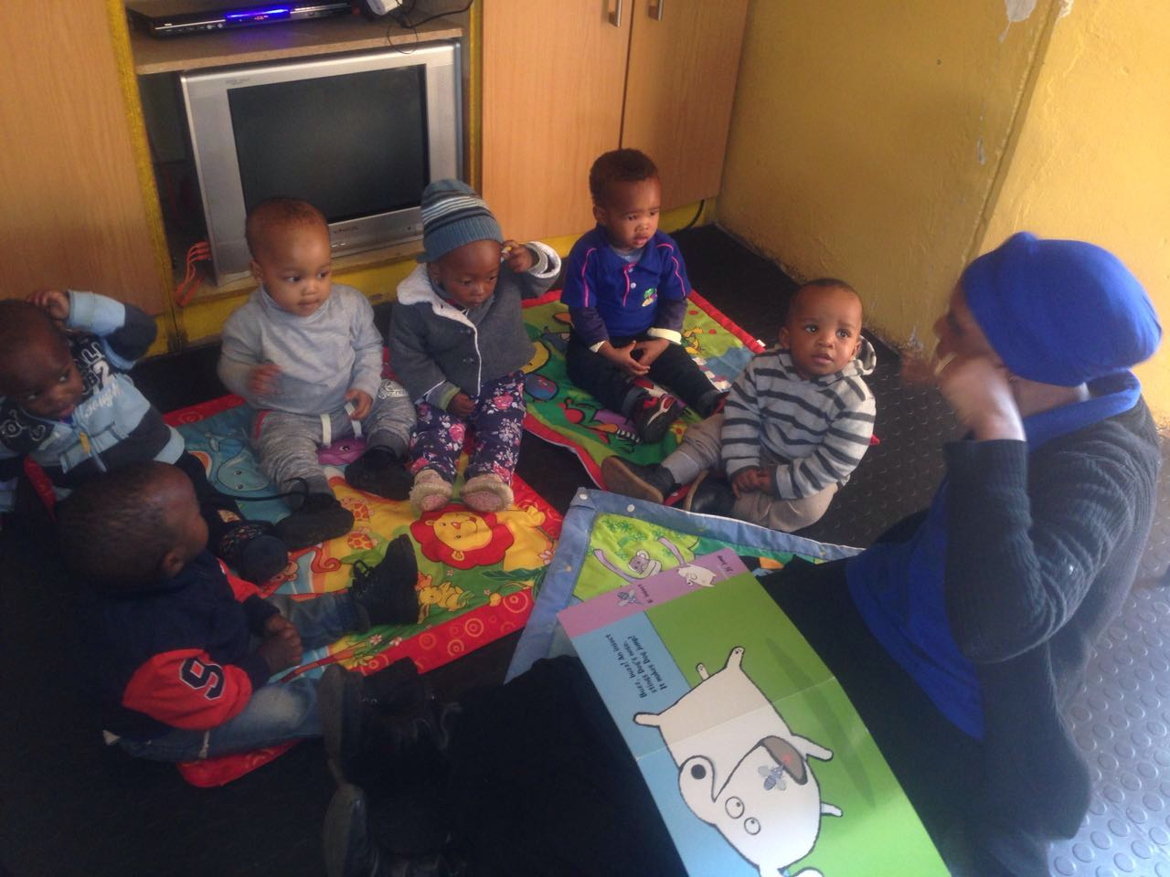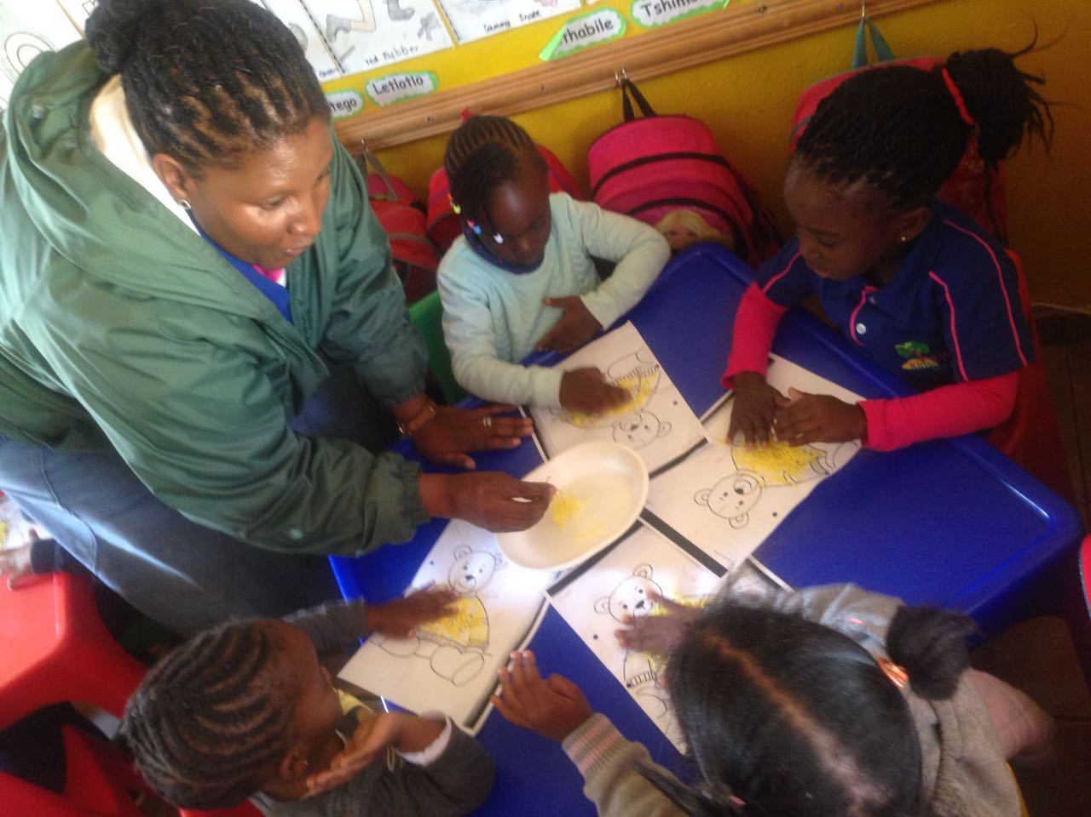PENGUIN CLASS TEADY BEAR (STORY TIME)

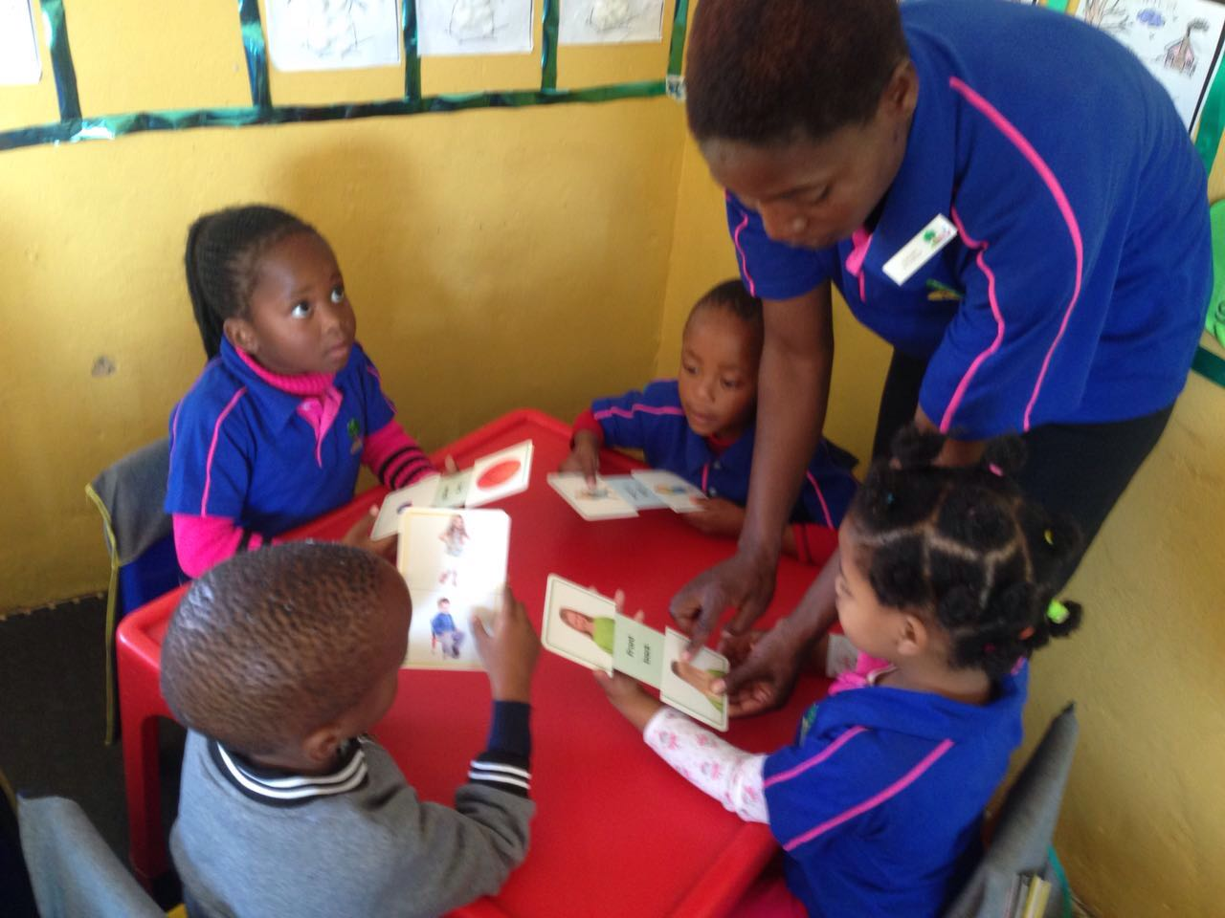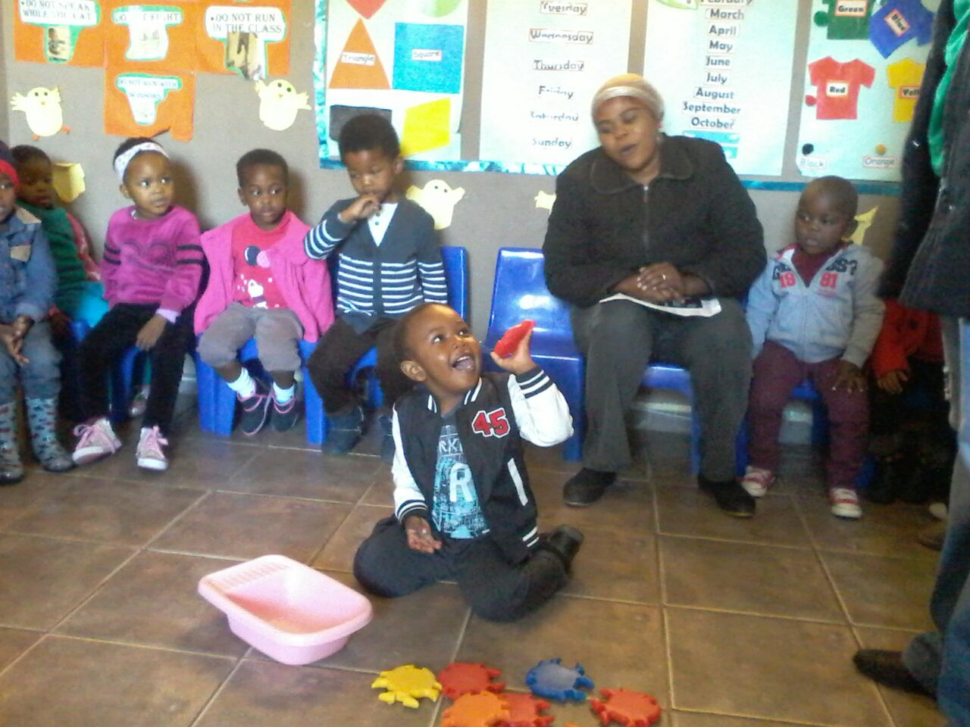DOLPHIN CLASS GIRAFFE CLASS (COUNTING)

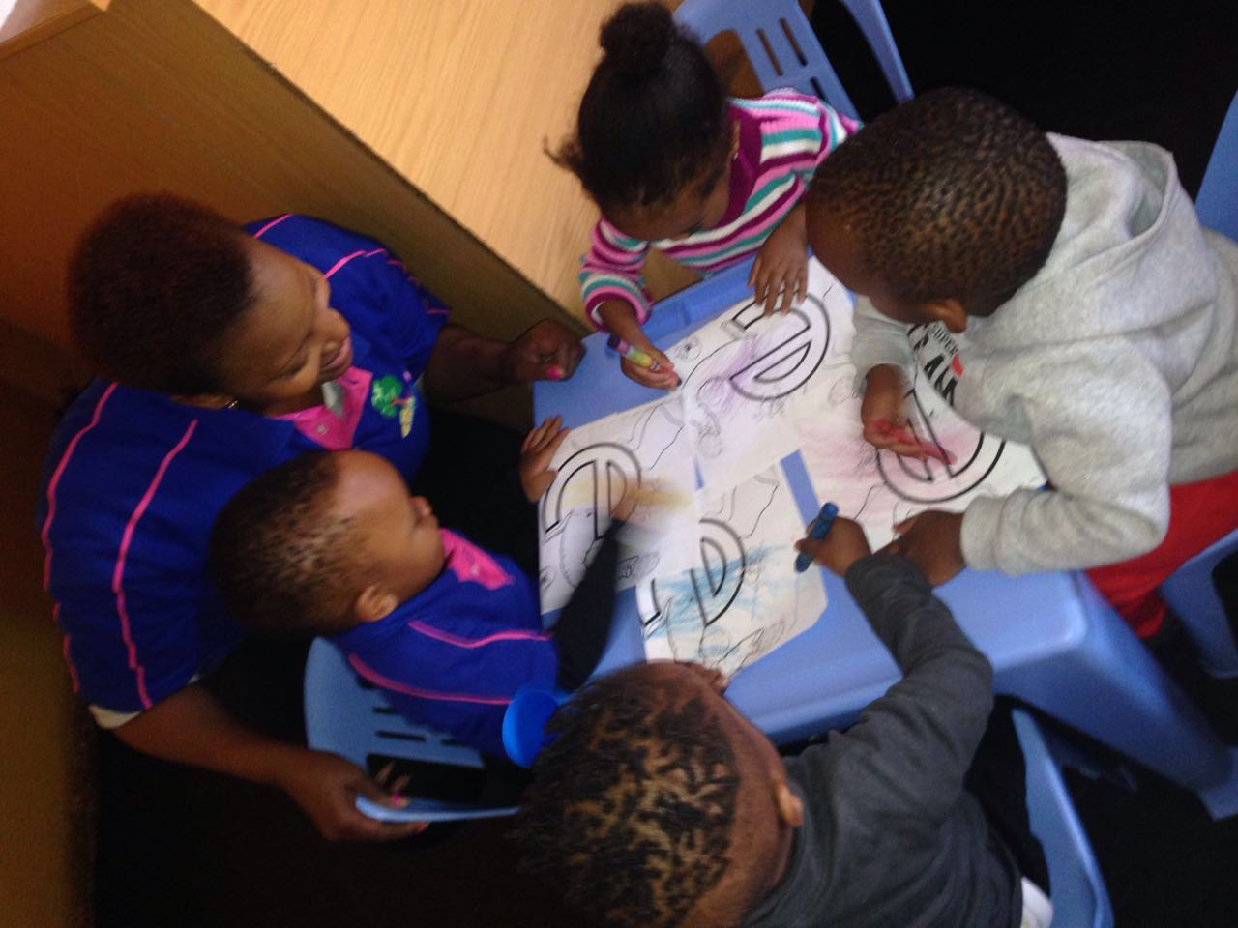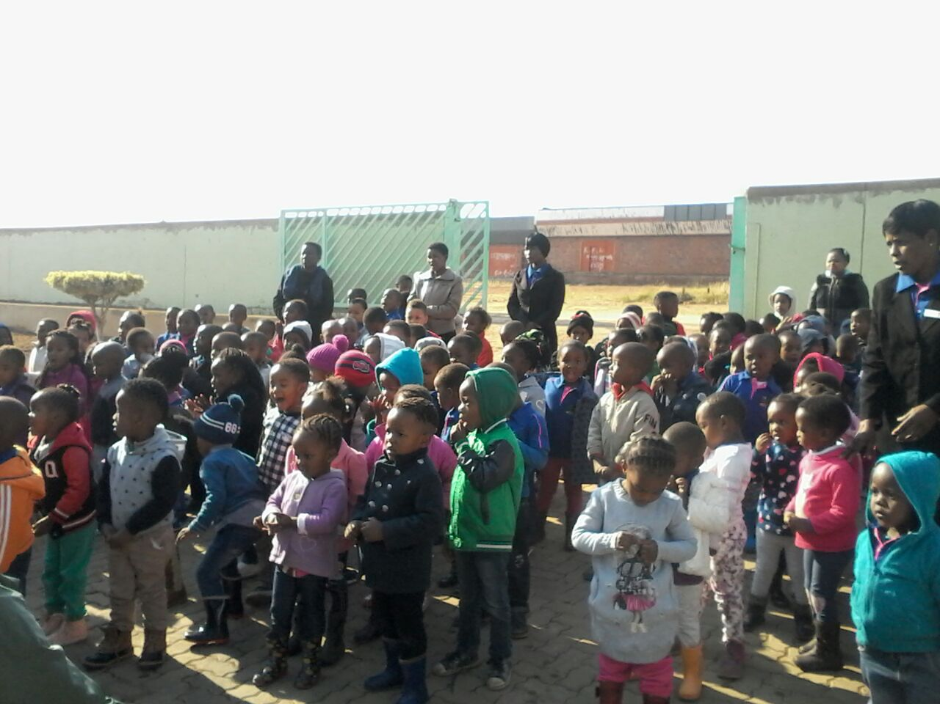CHAMELEON CLASS

***ASSMBLY***

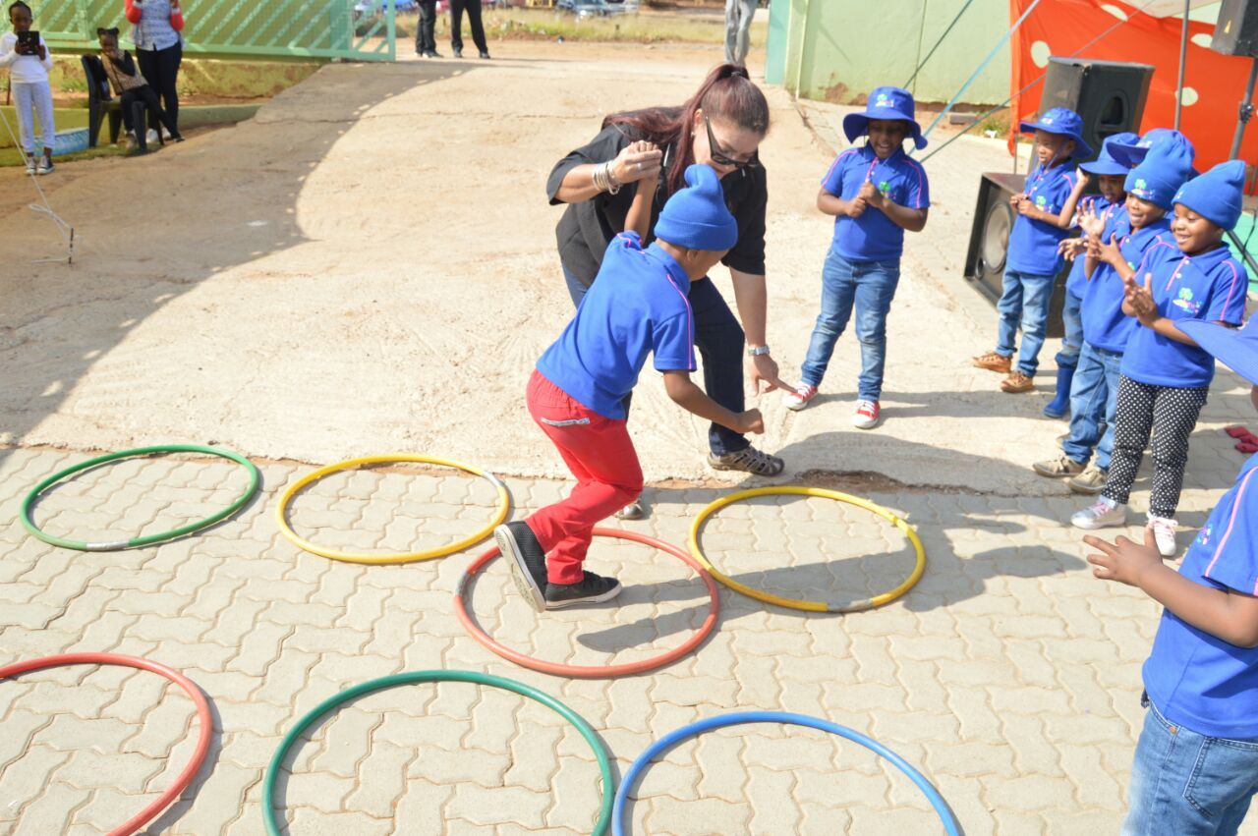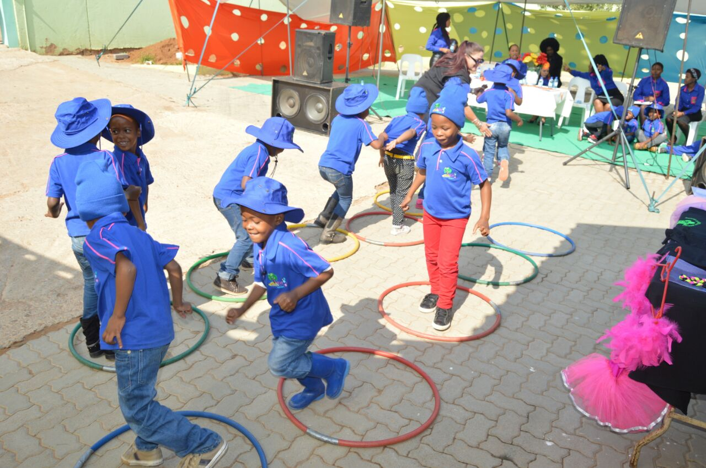***Action ball***

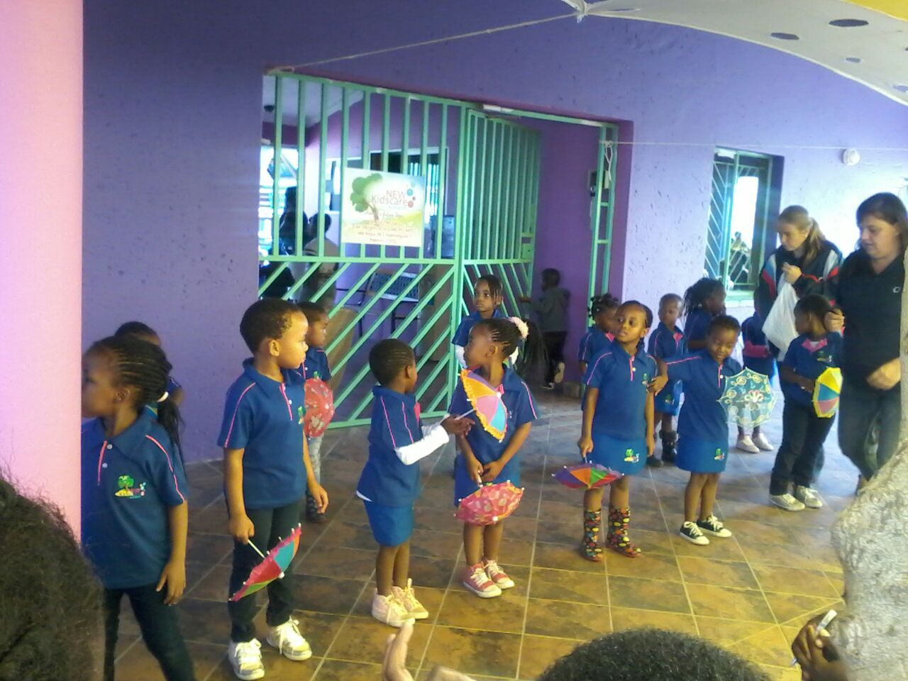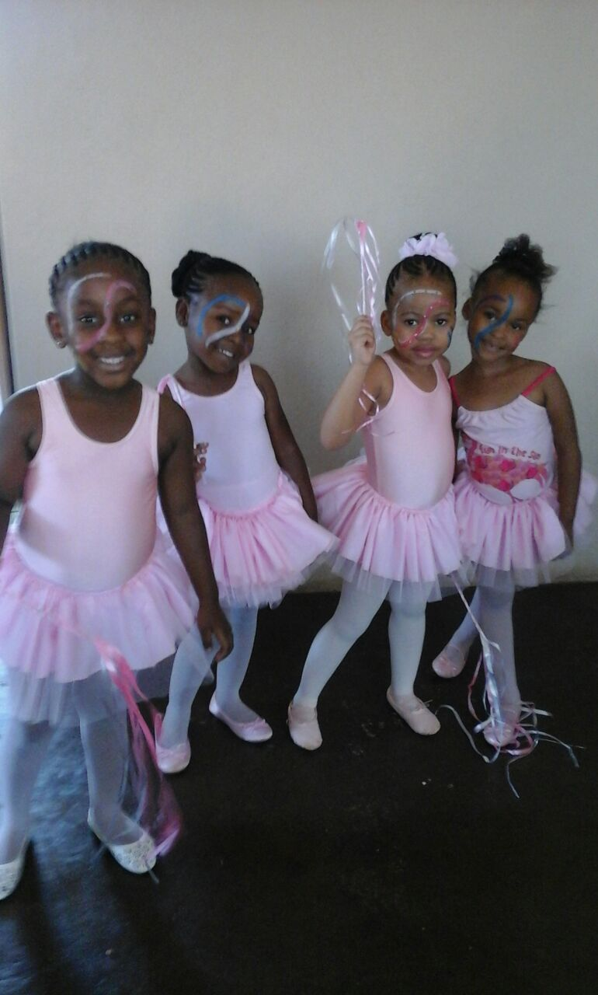***BALLET***

***KIND REGARDS***

***NTHABI & NKC TEAM***